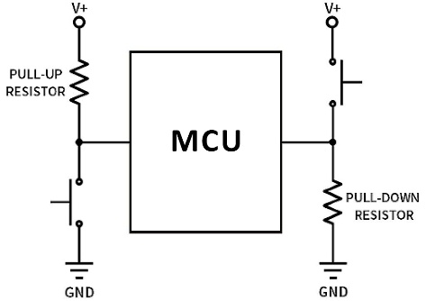 **Pull-up and pull-down circuits**

* Pull-up and pull-down circuits are used to ensure that

pins on a microcontroller have a known voltage level

before they are actively driven by other components.

**Liquid Crystal Display LCD**

LCD I2C (i²c)

i2c bridgeing connection charts

SetCursor (0,0)

|  |  |  |  |  |  |  |  |  |  |  |  |  |  |  |  |  |
| --- | --- | --- | --- | --- | --- | --- | --- | --- | --- | --- | --- | --- | --- | --- | --- | --- |
|  | 1 | 2 | 3 | 4 | 5 | 6 | 7 | 8 | 9 | 10 | 11 | 12 | 13 | 14 | 15 | 16 |
| 1 |  |  |  |  |  |  |  |  |  |  |  |  |  |  |  |  |
| 2 |  |  |  |  |  |  |  |  |  |  |  |  |  |  |  |  |

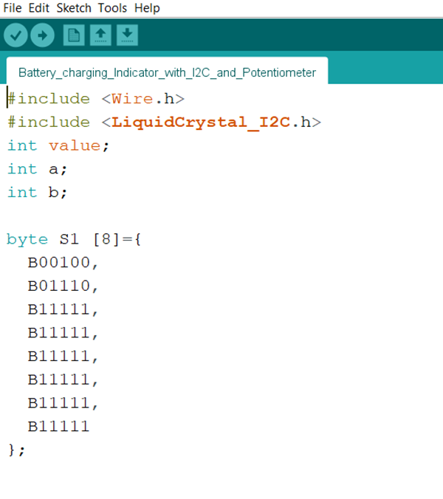

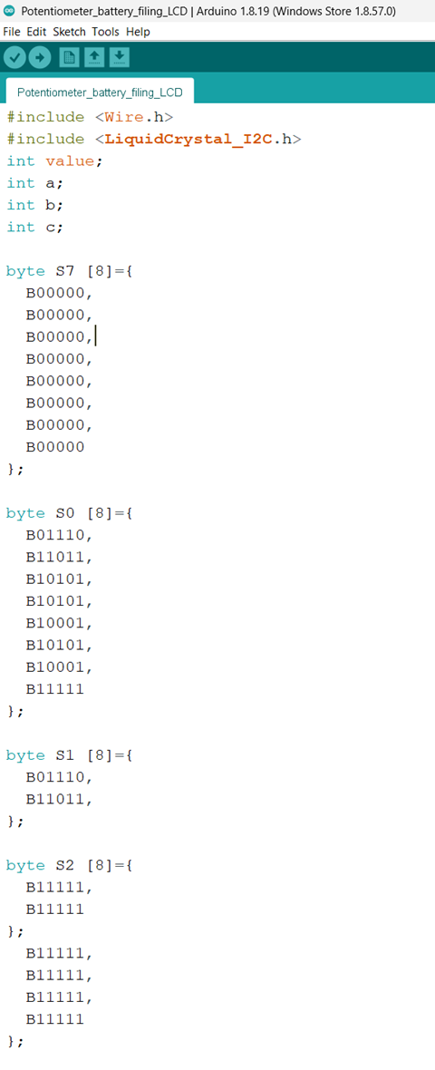

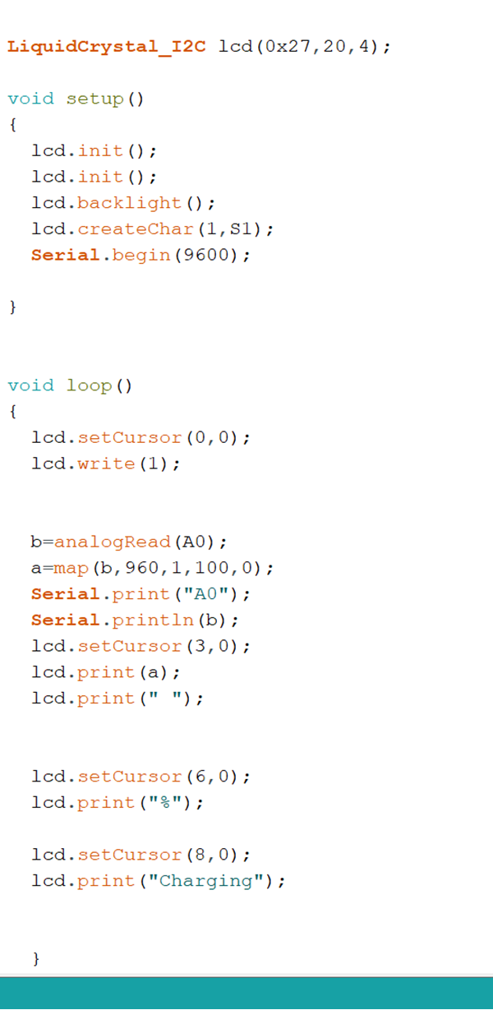

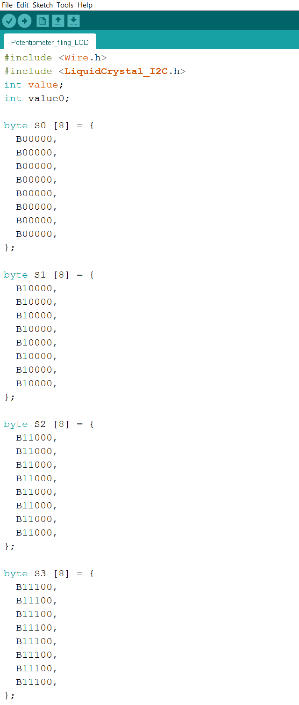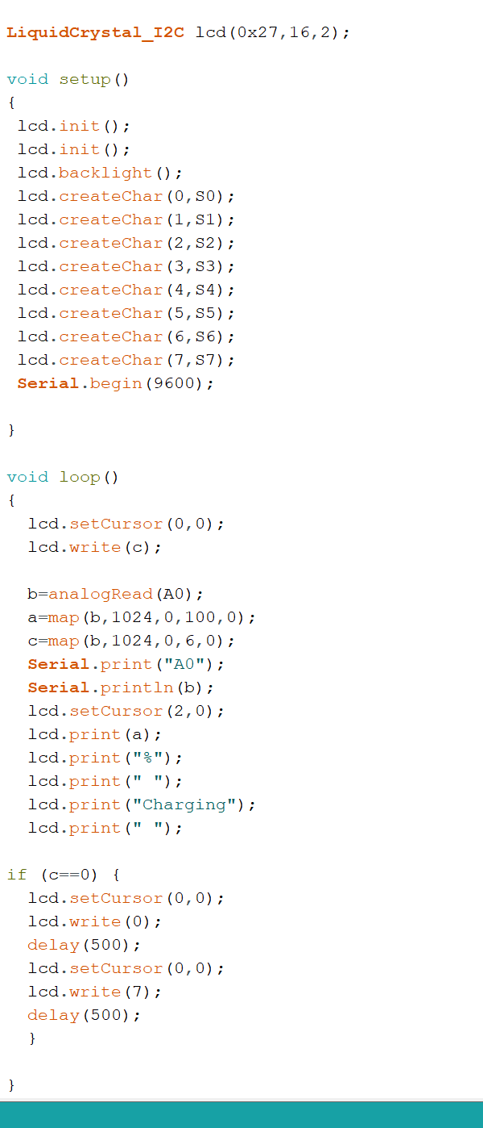

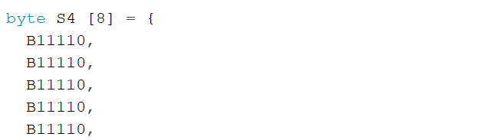

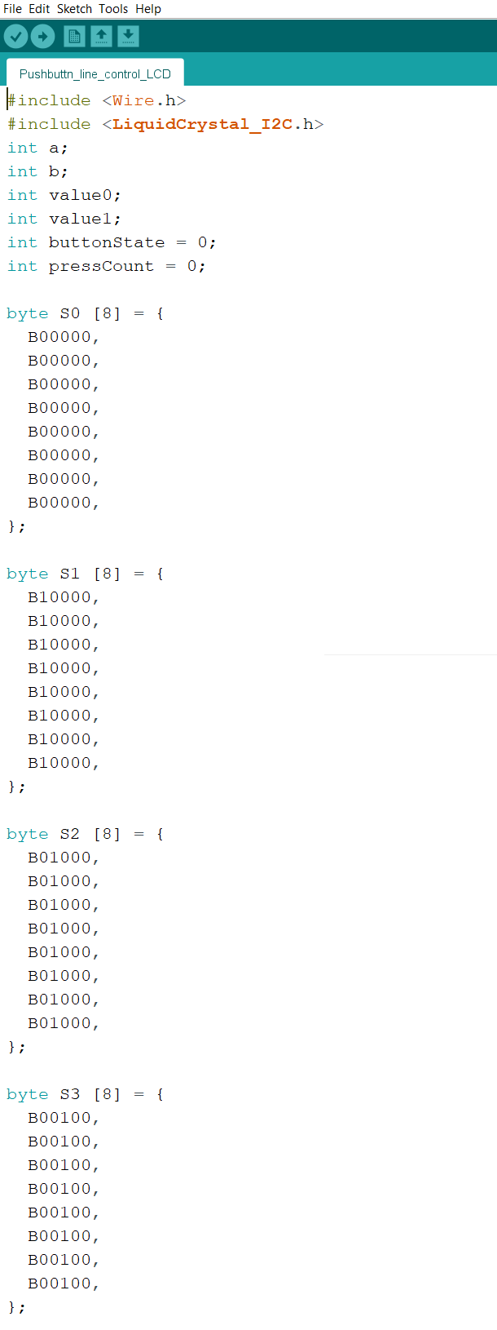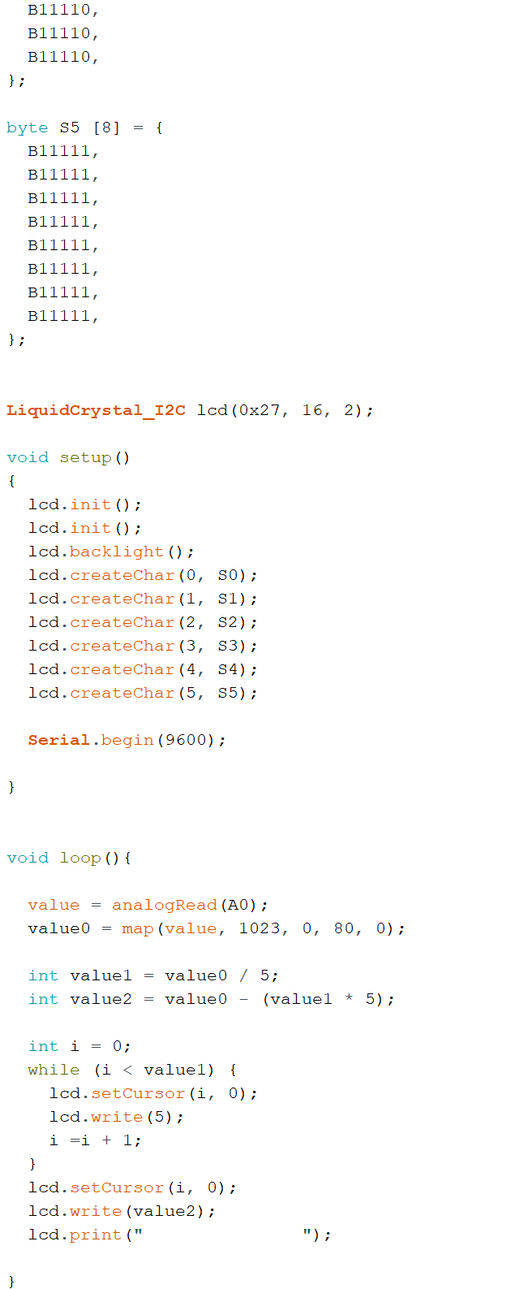



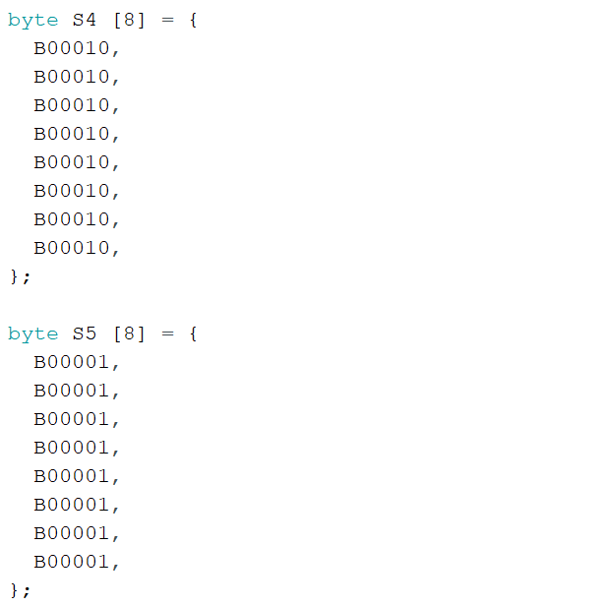

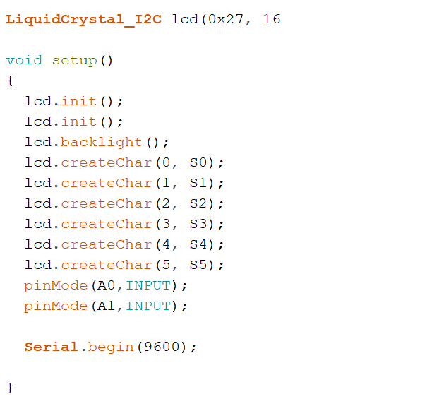

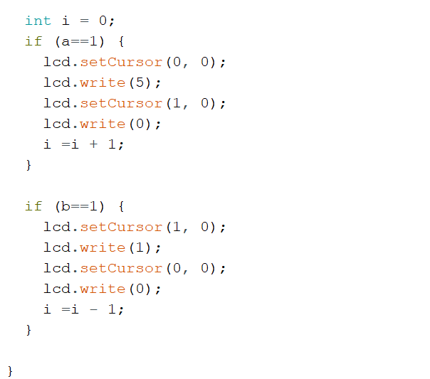

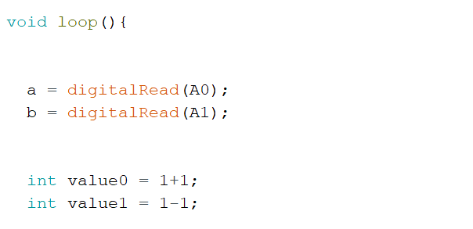



**Ultrasonic Sensor**

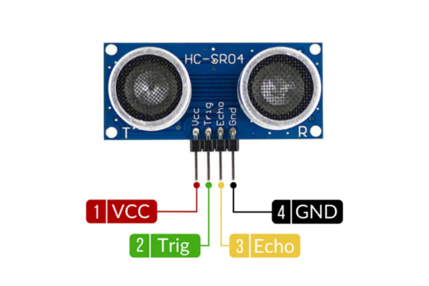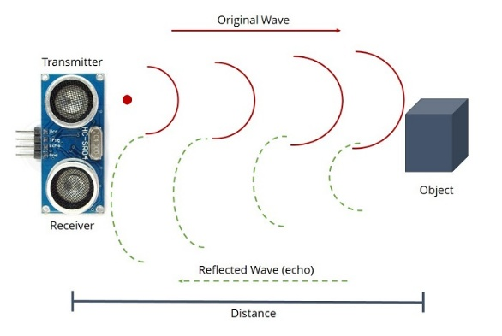

* Calculate the target’s distance by emitting ultrasonic sound waves and converting them

into electrical signals.

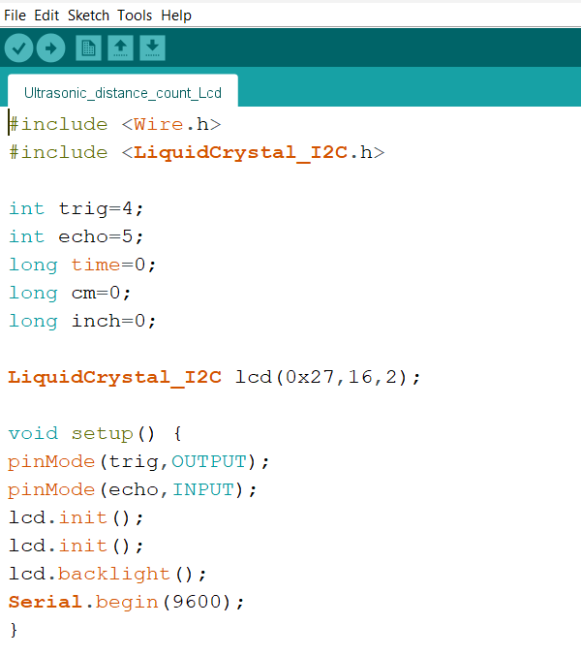

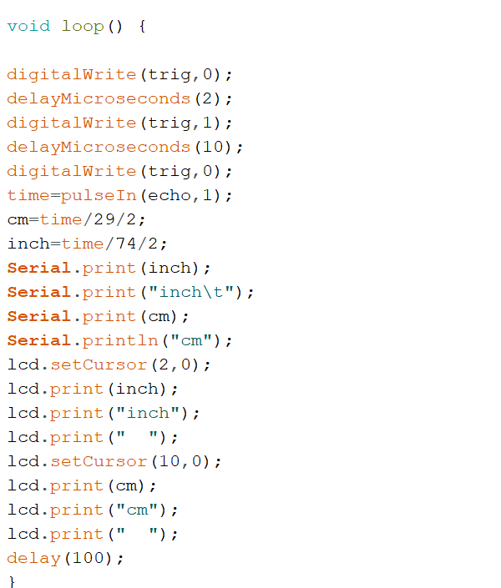



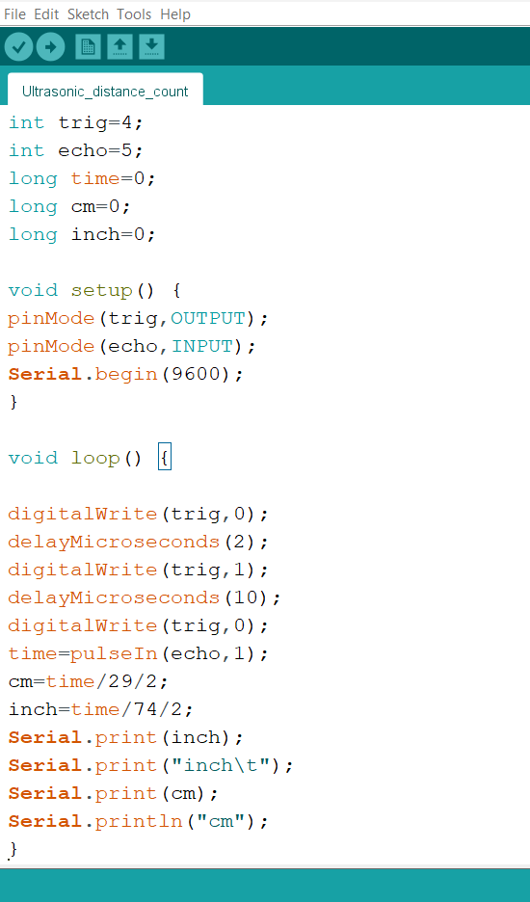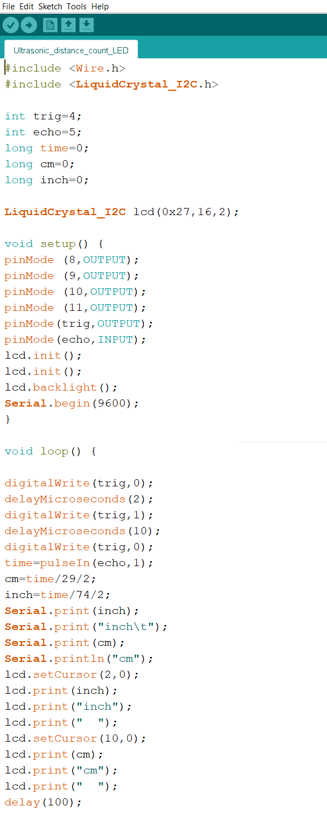

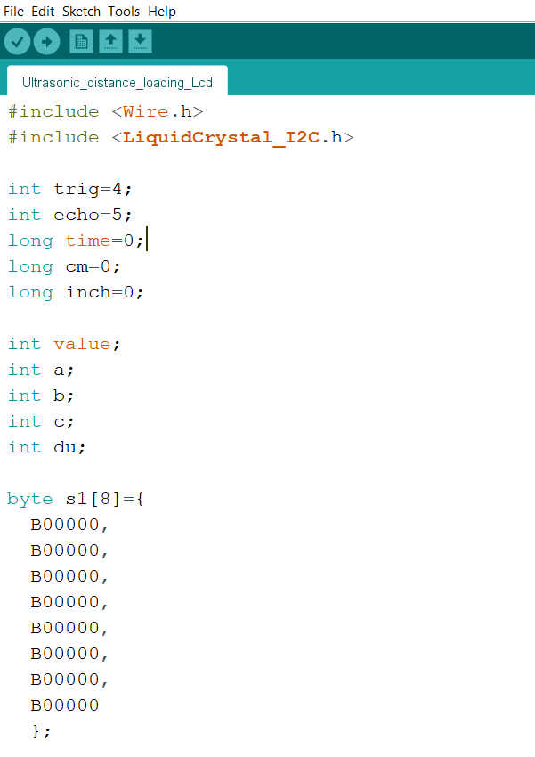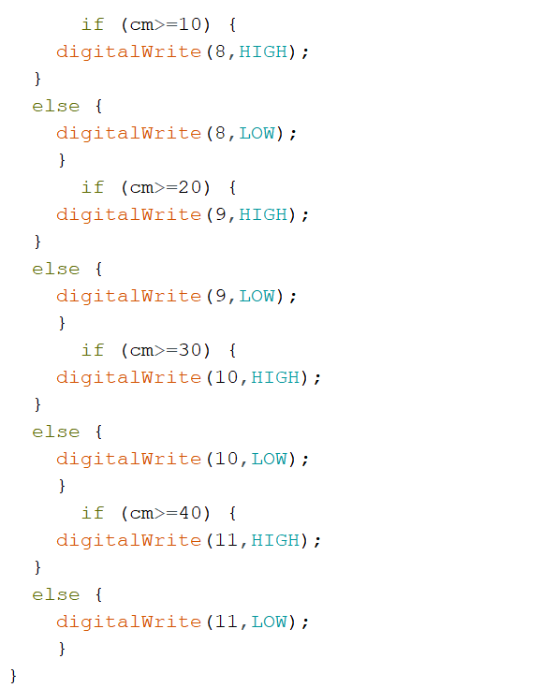



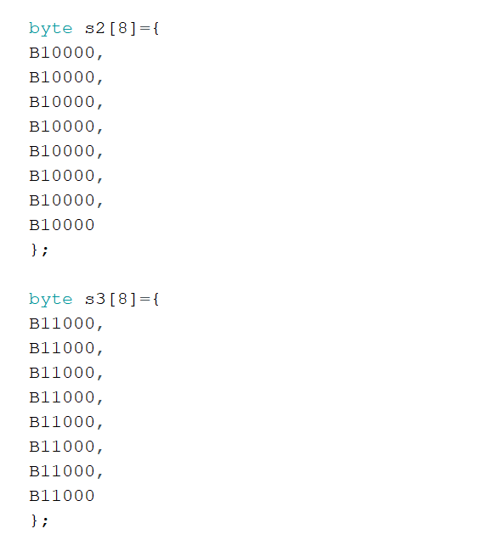

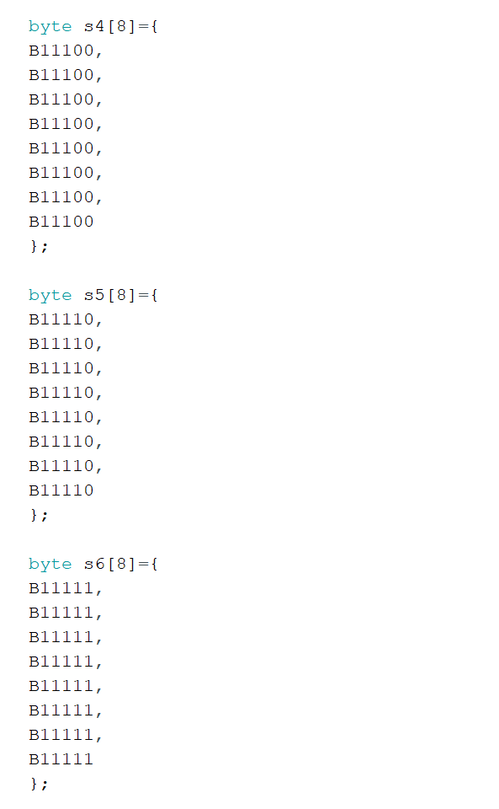

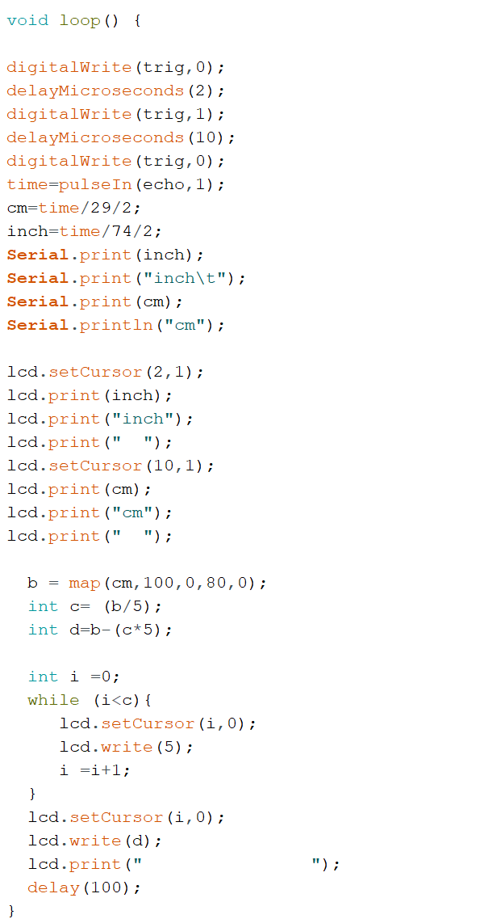

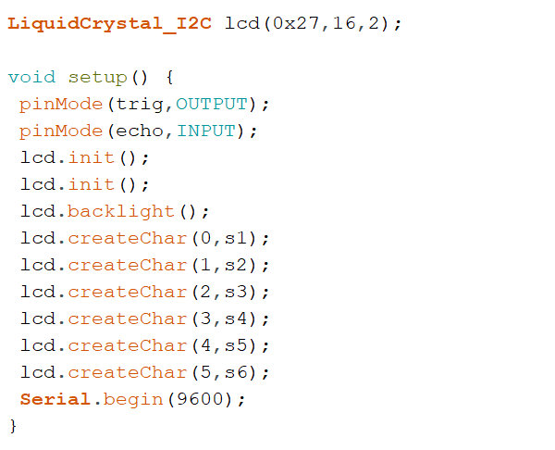



**Seven Segment Display**

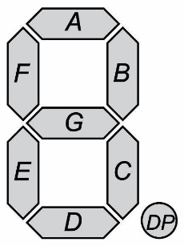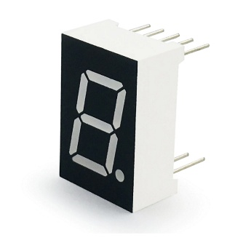

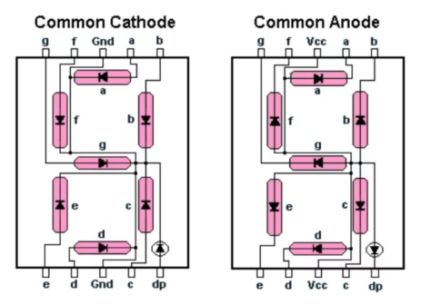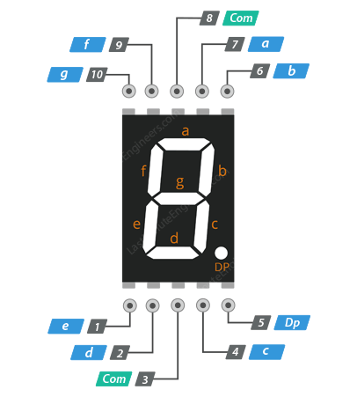

* Seven segment display is an electronic display device used to show decimal numbers from

0 to 9. It consists of seven segments.

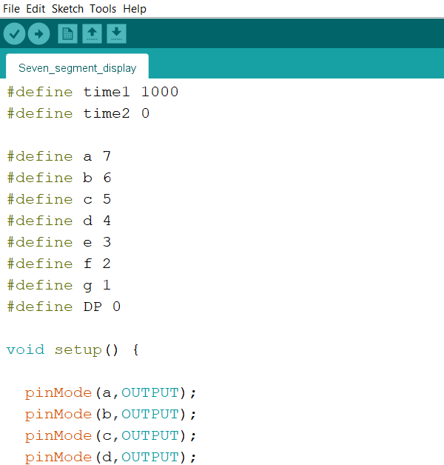

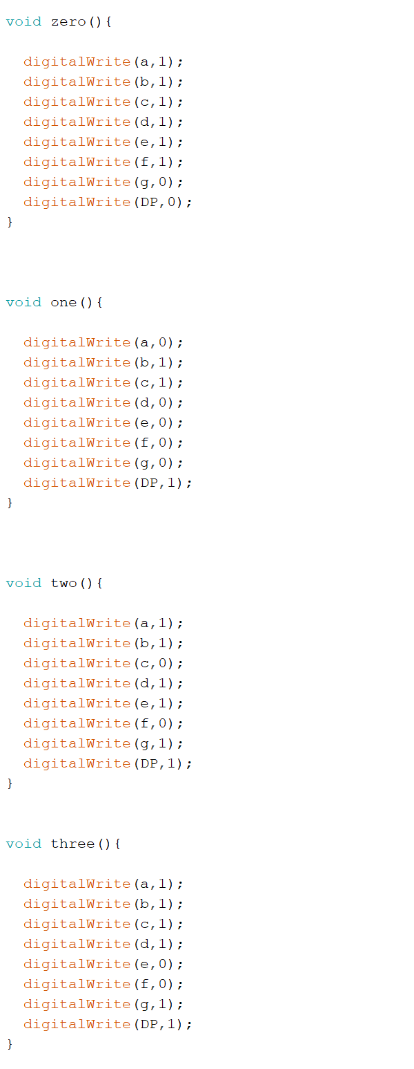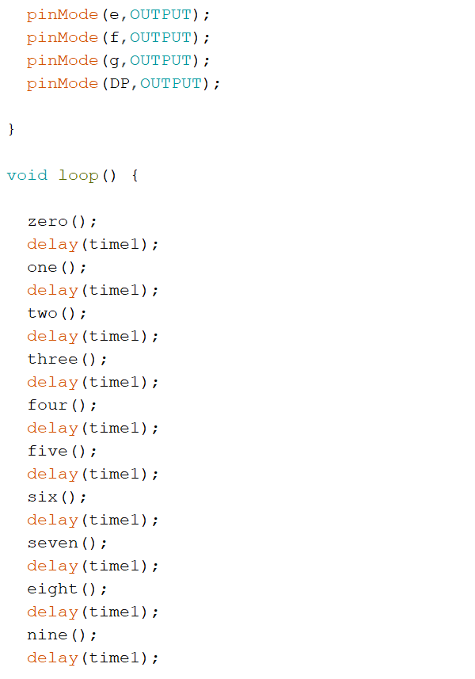

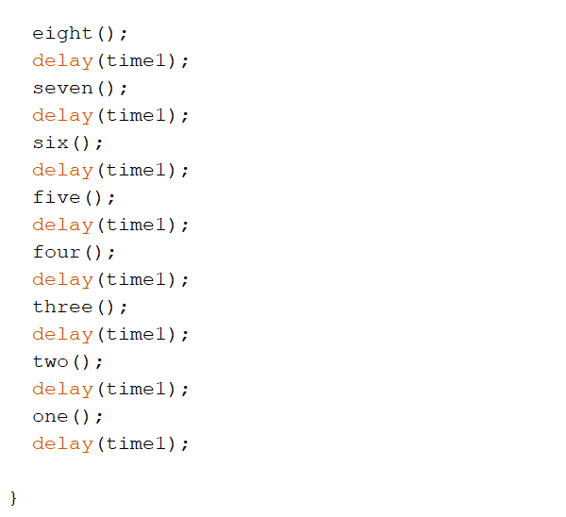

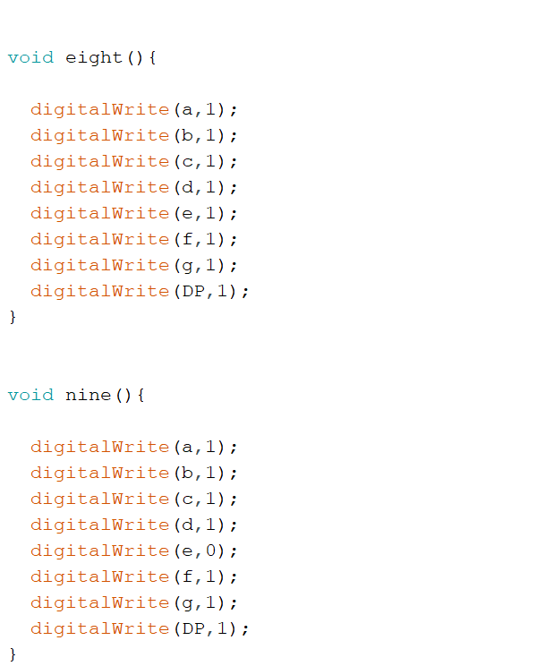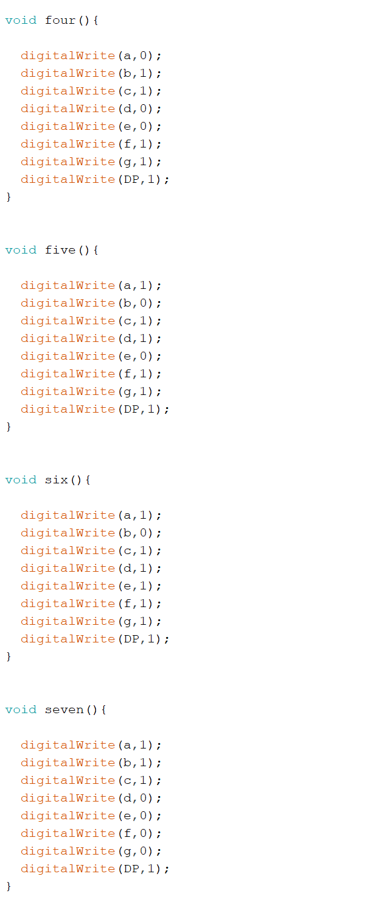

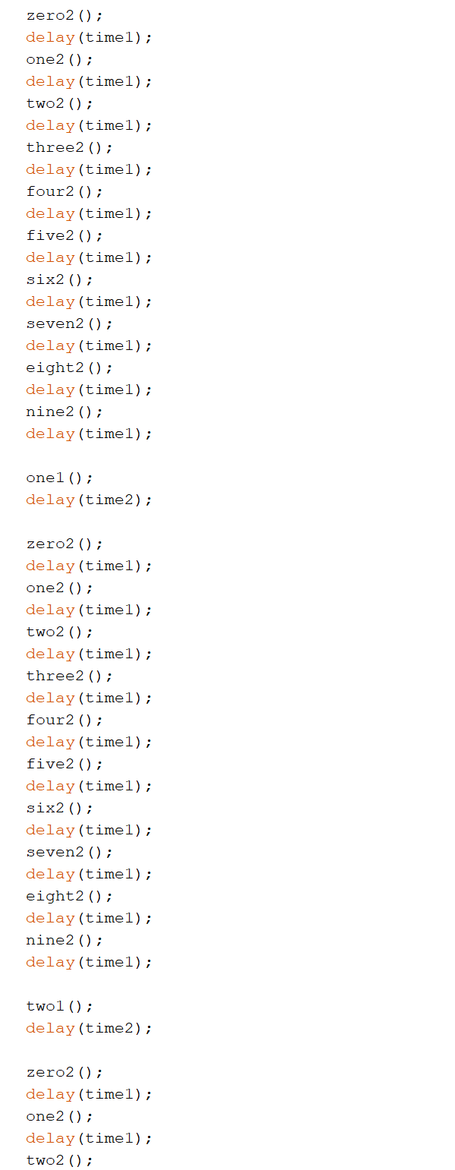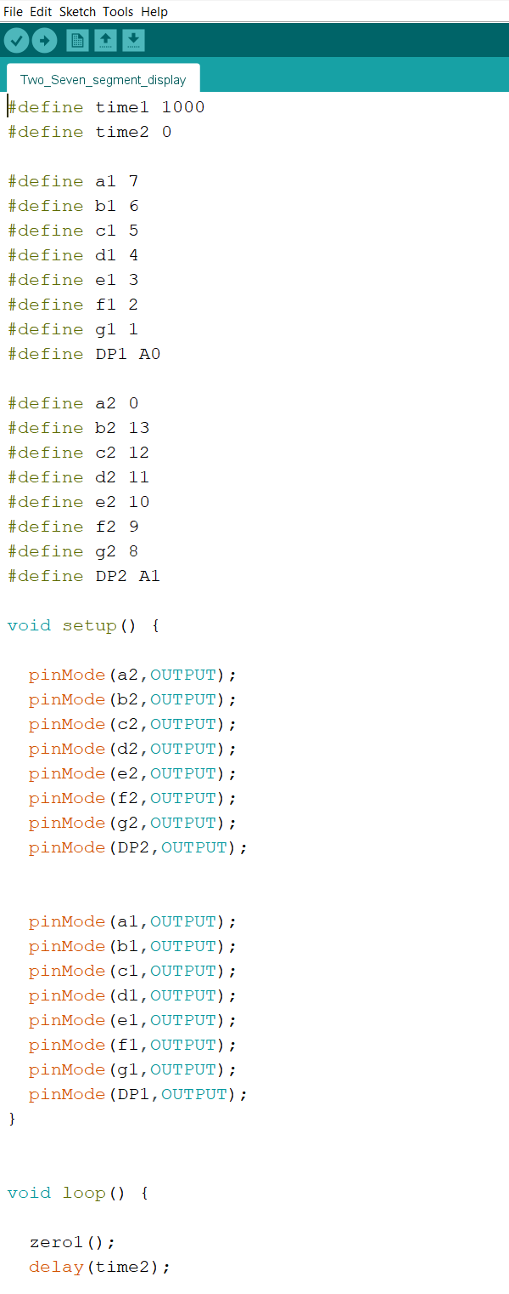

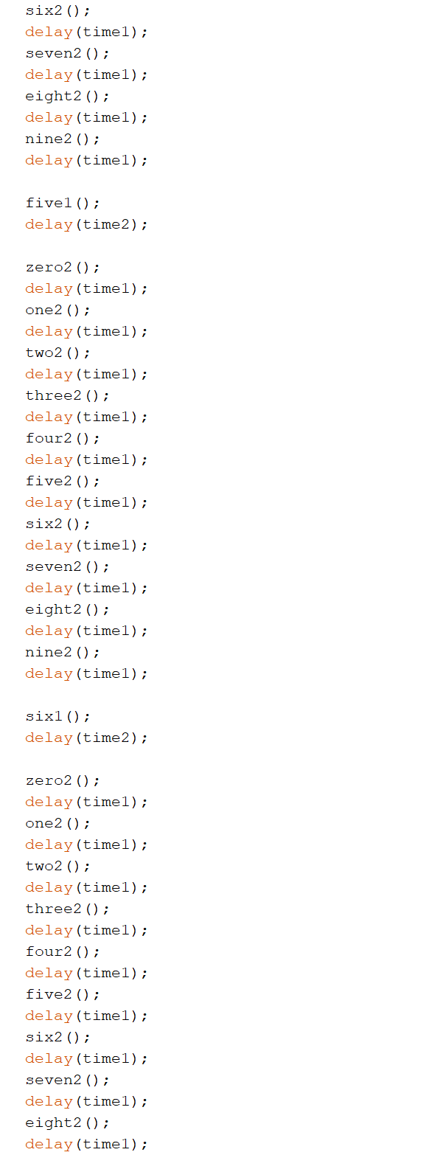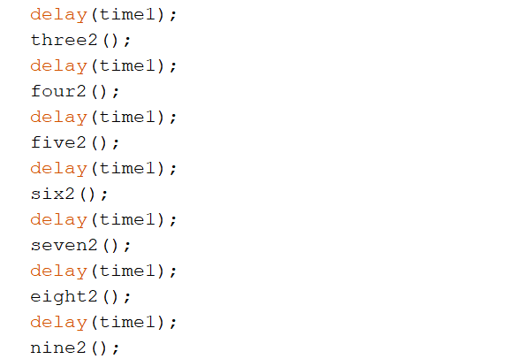

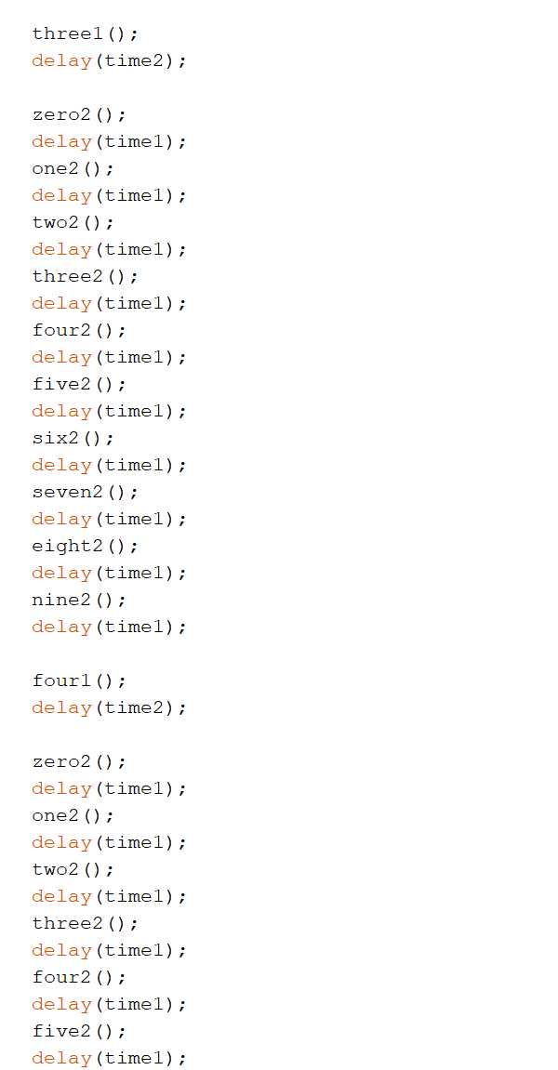

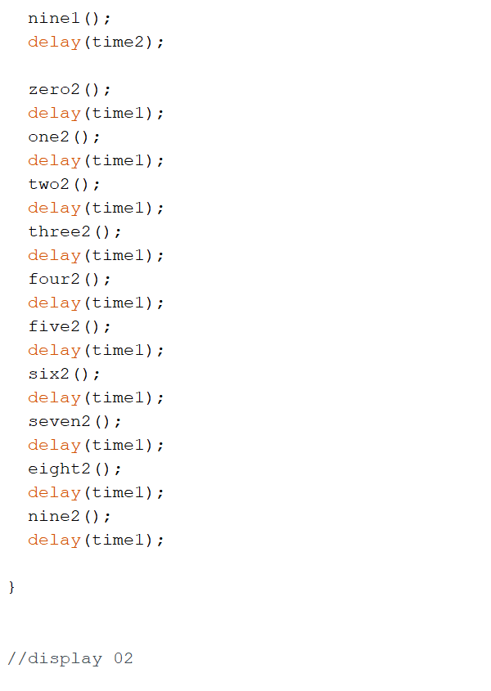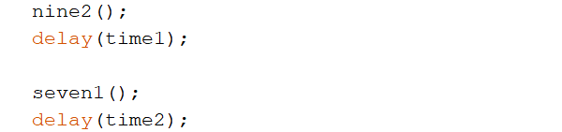

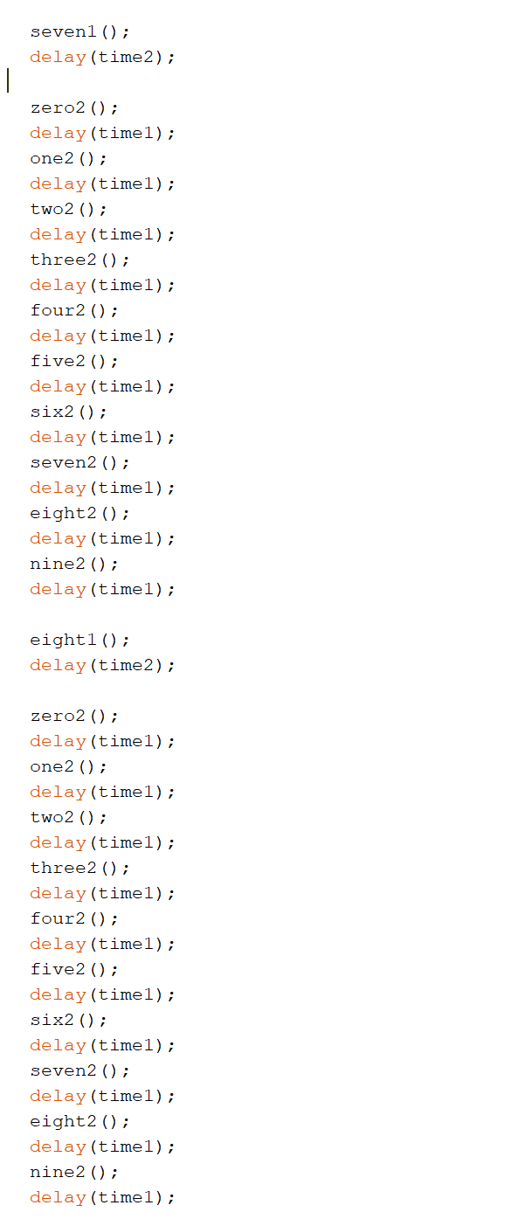

T V S H O W G I F S

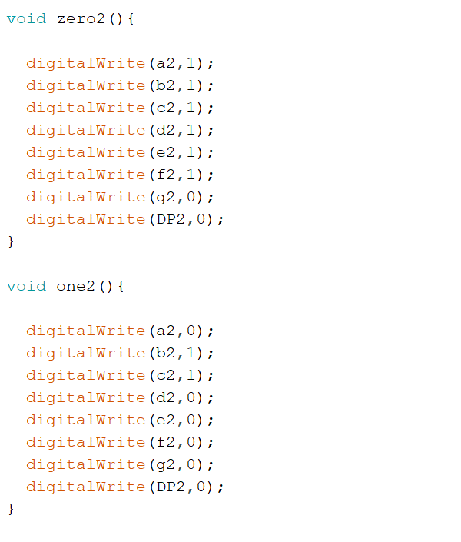

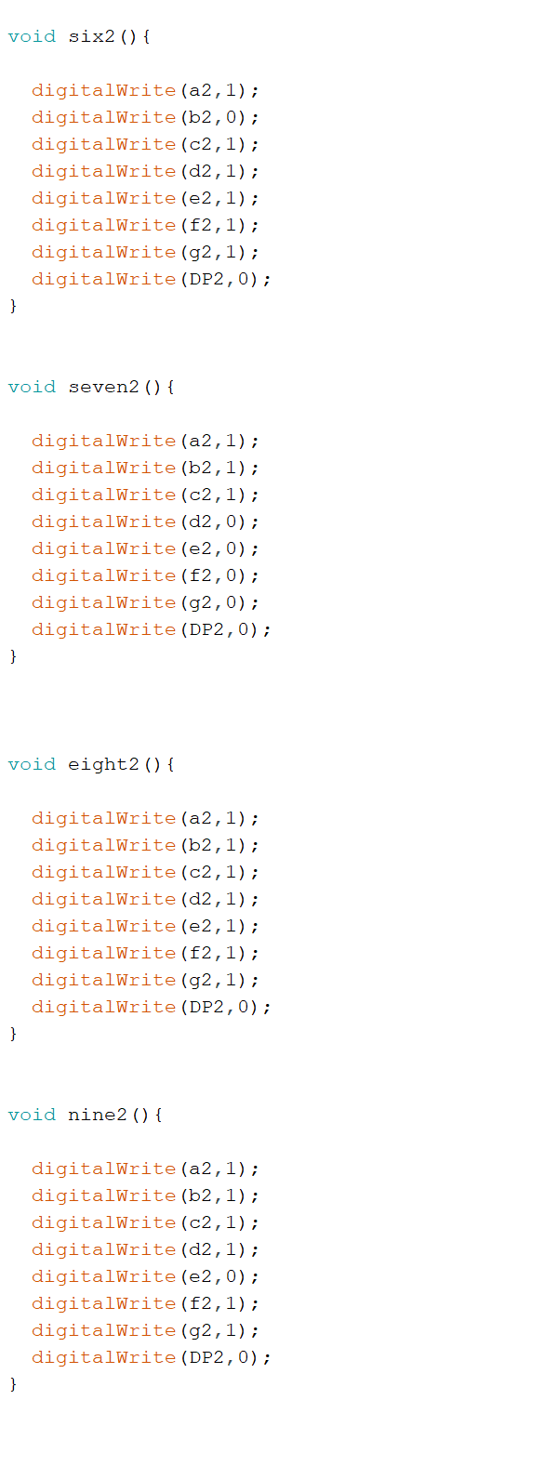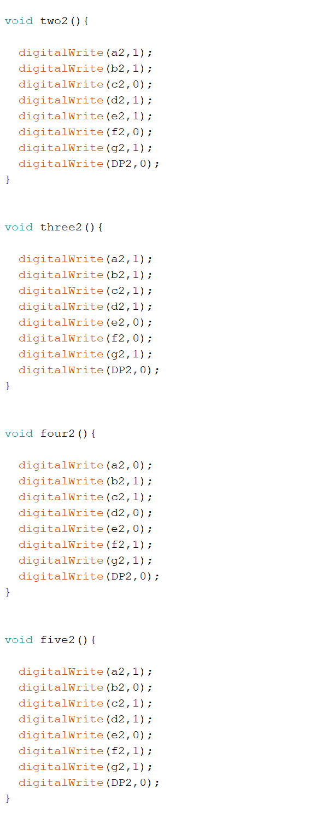

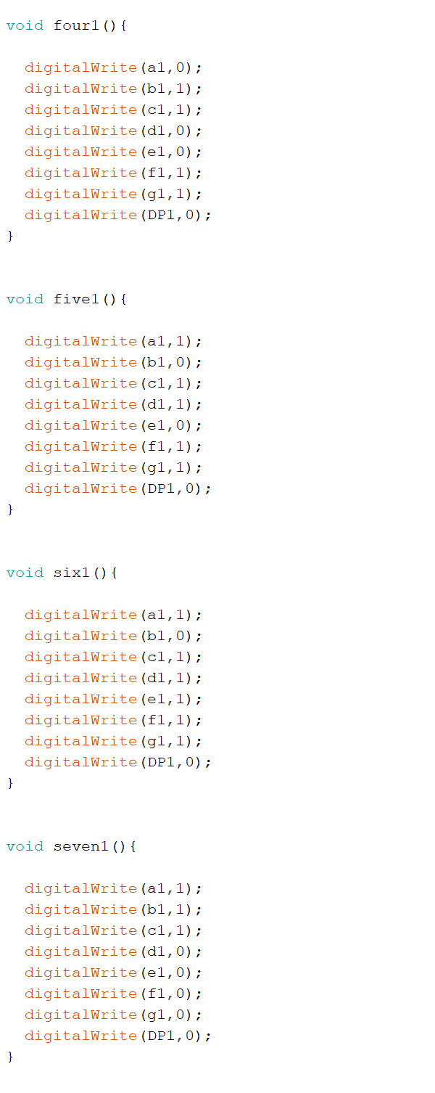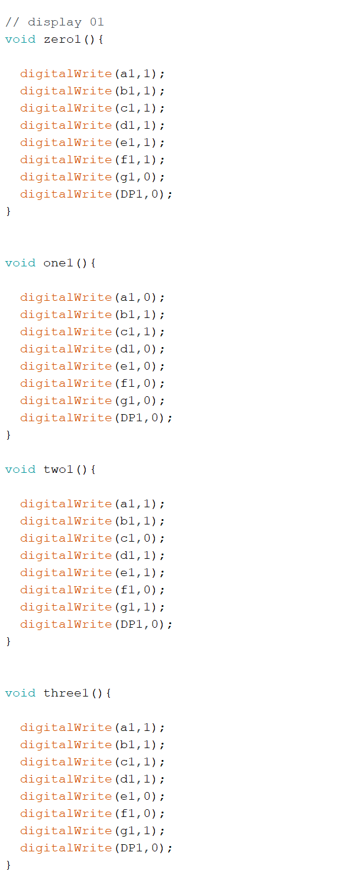

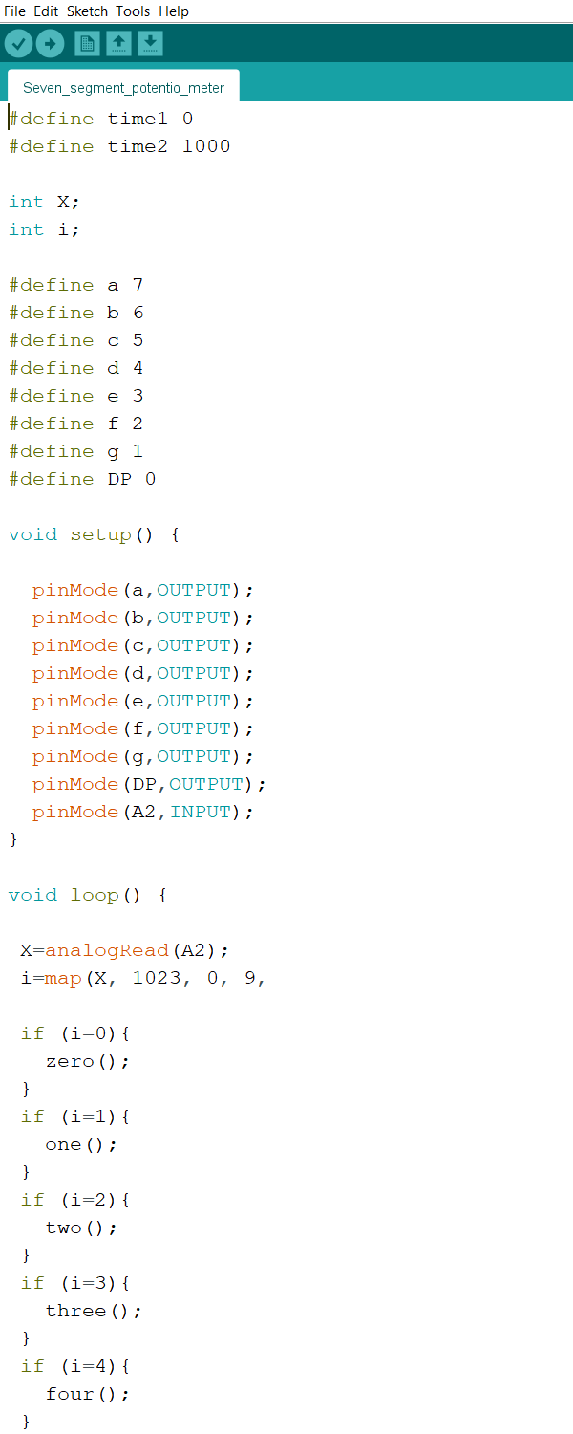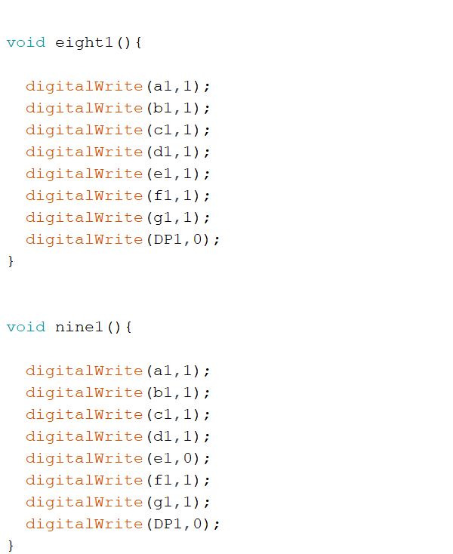



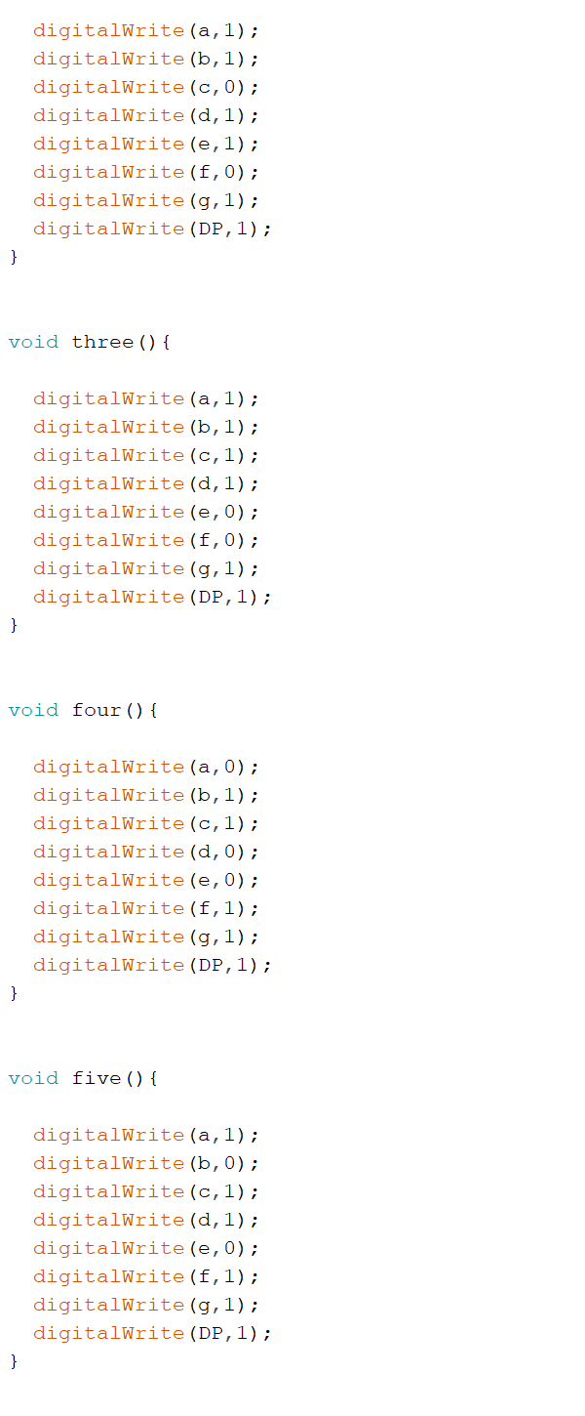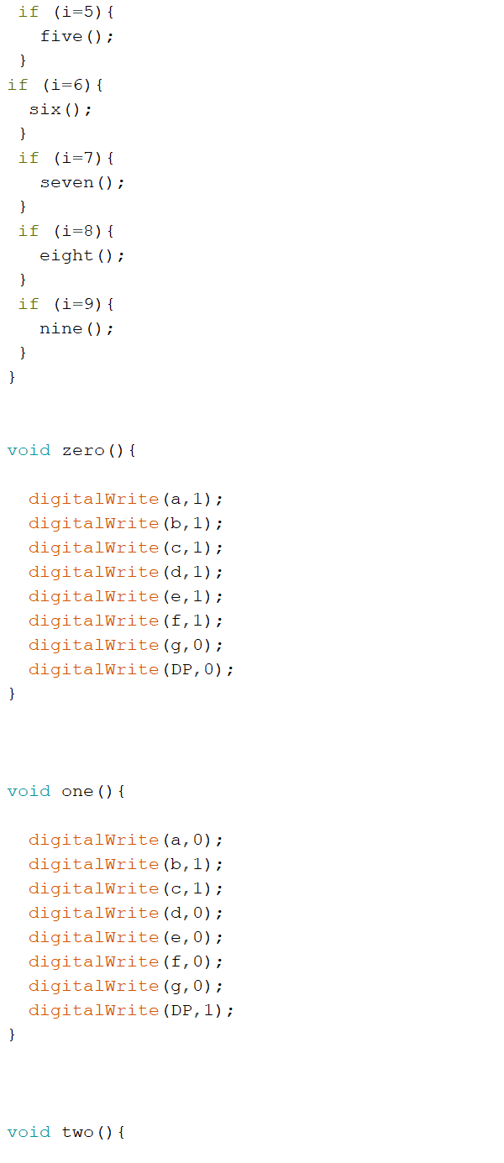

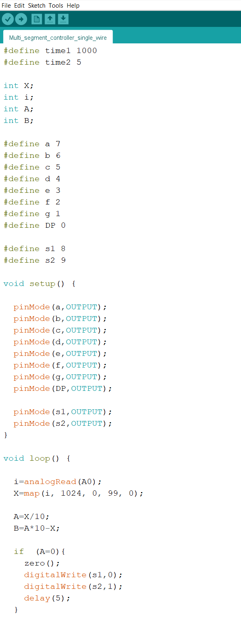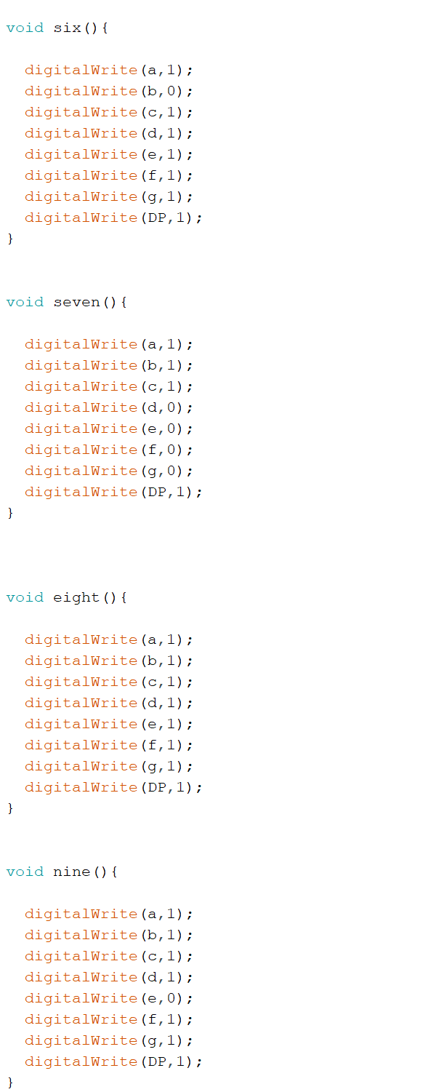



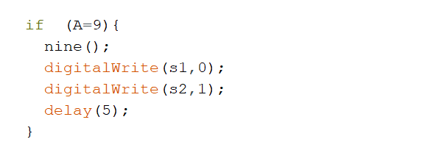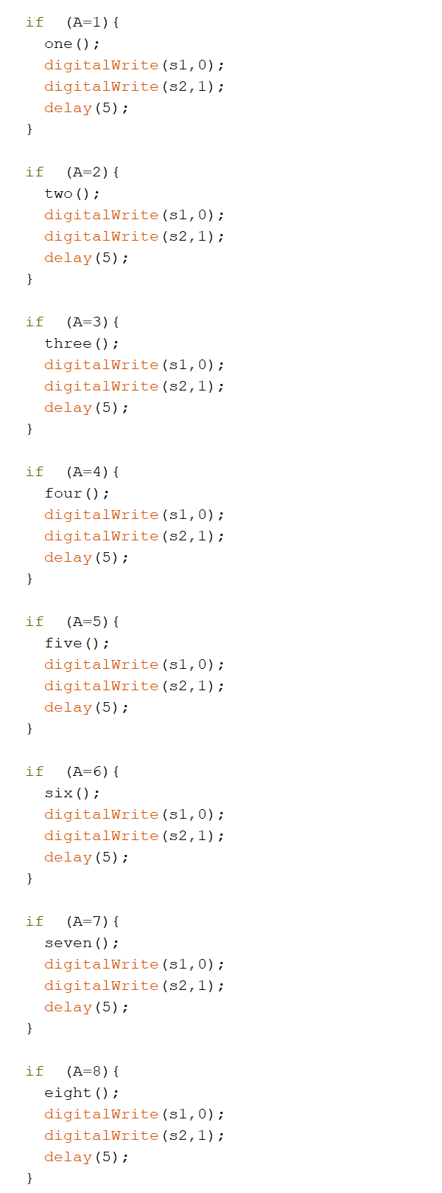

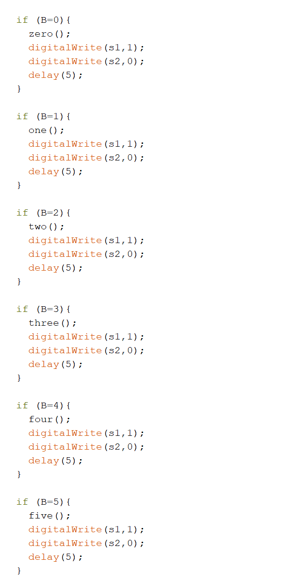

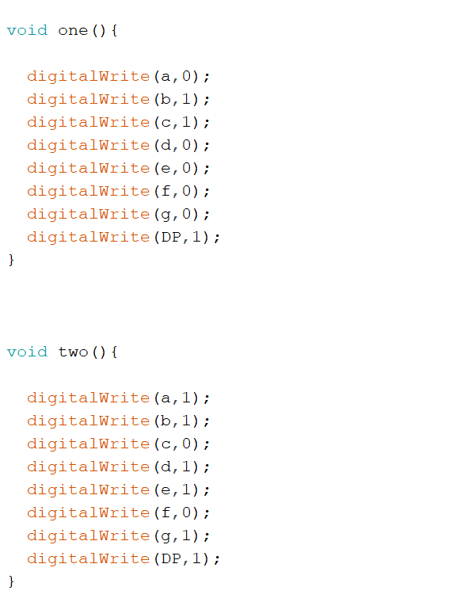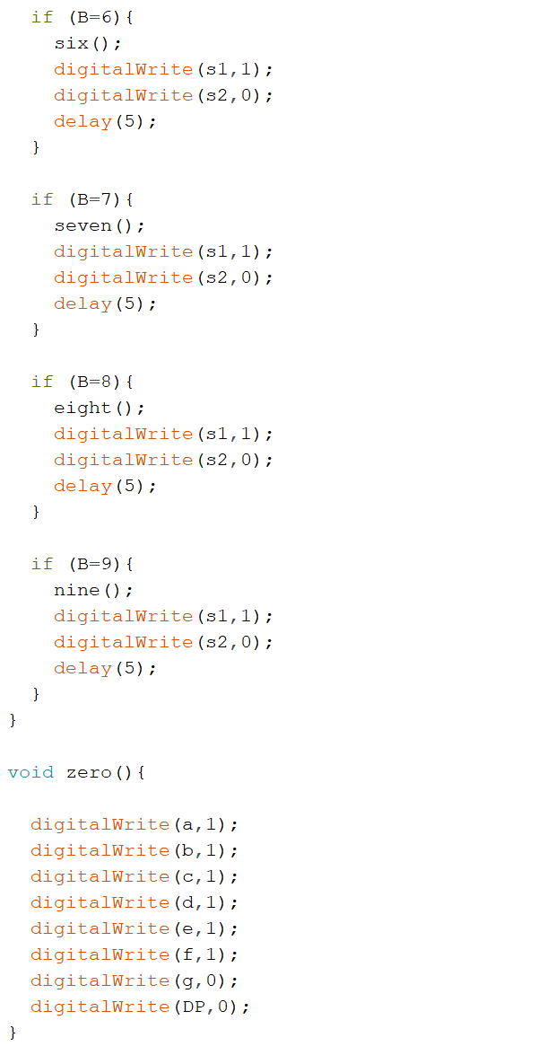

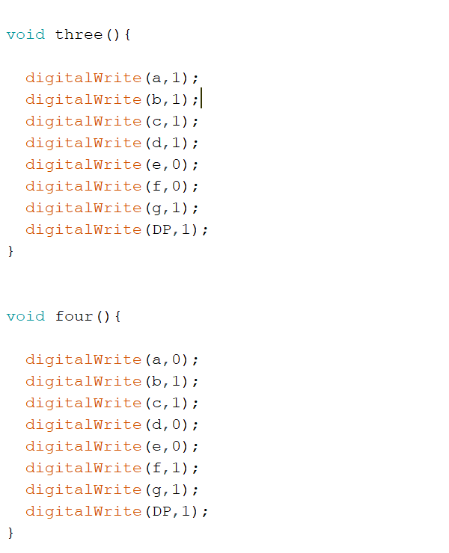

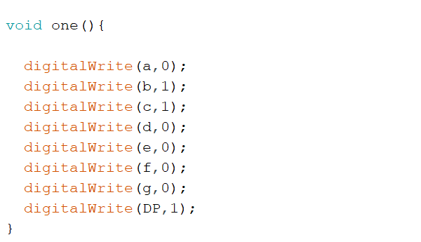

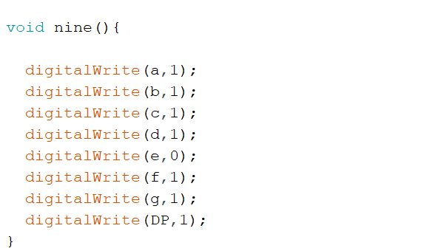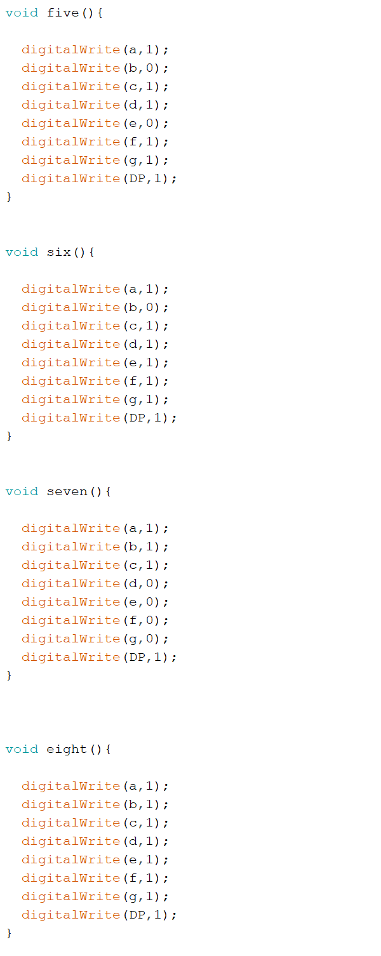



**Joystick Module**

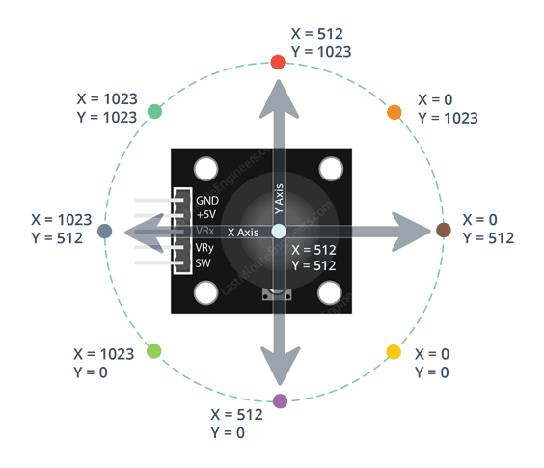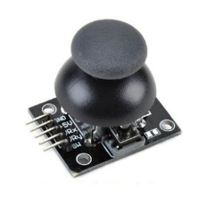

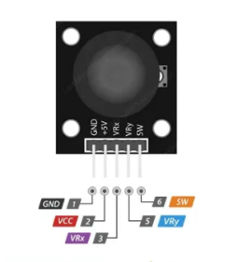

* Joystick module typically has 5 pins. The pinout for a Dual Axis XY Joystick Module typically

includes five pins, arranged in a row or a column.

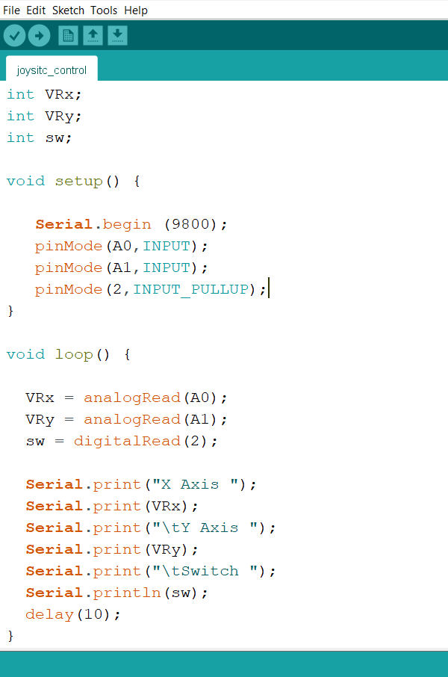

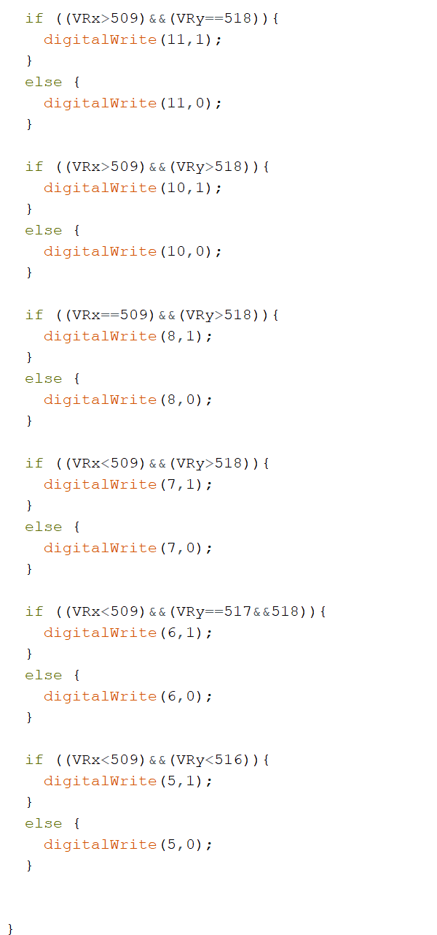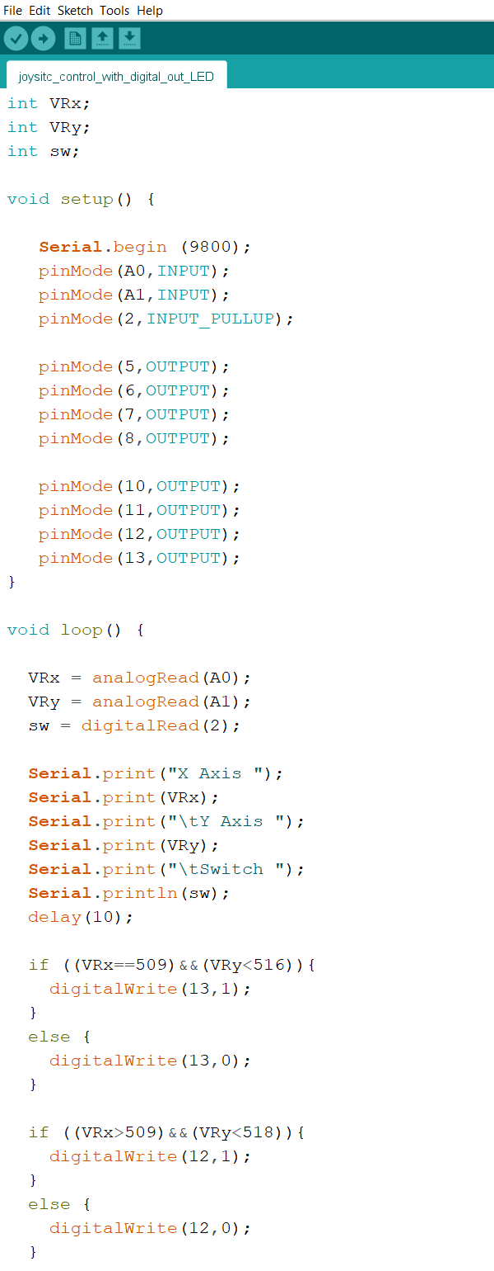



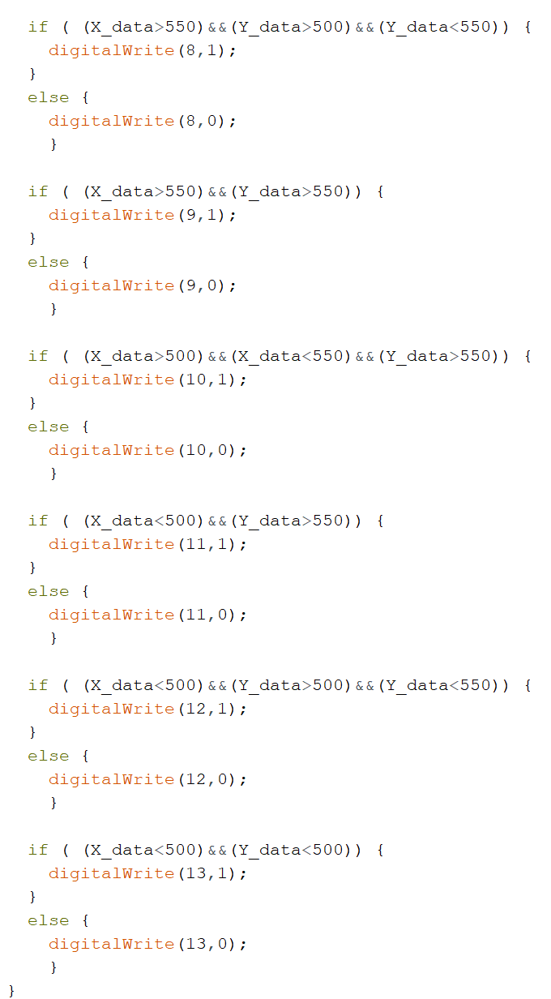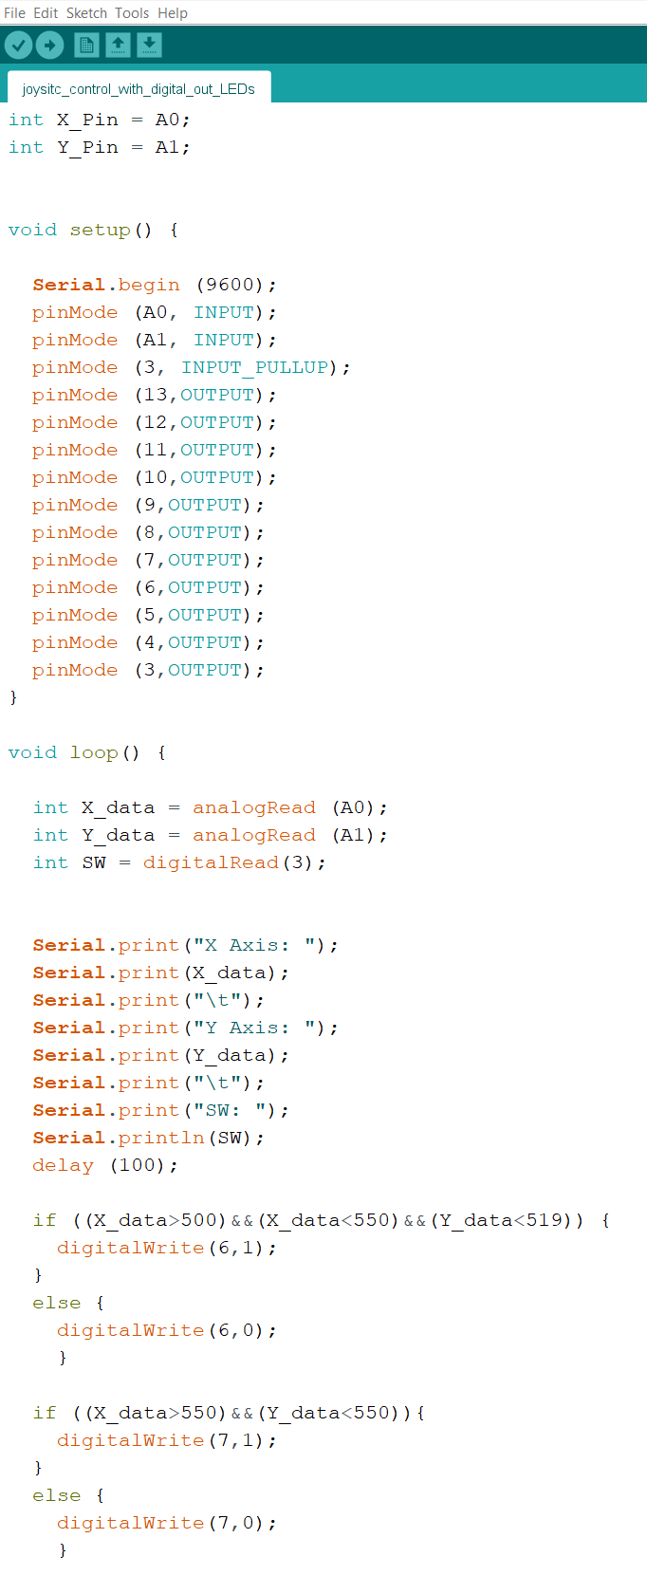



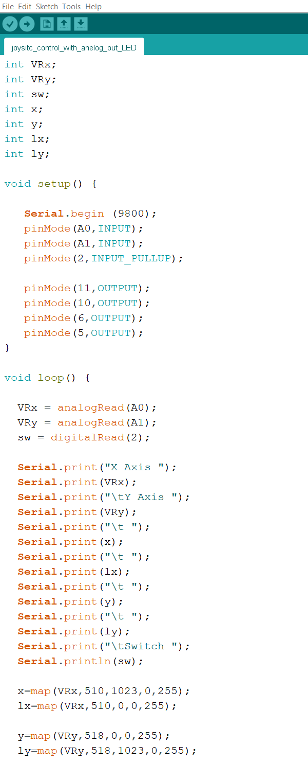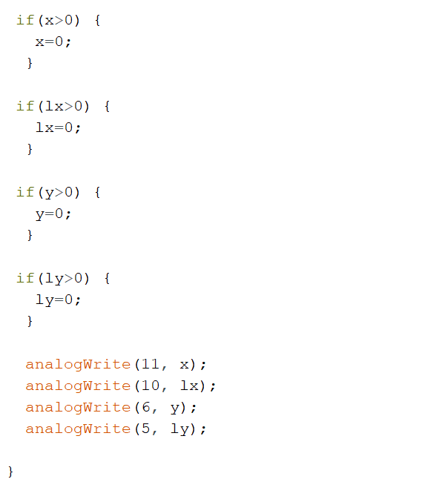



**Pulse Width Modulation (PWM)**

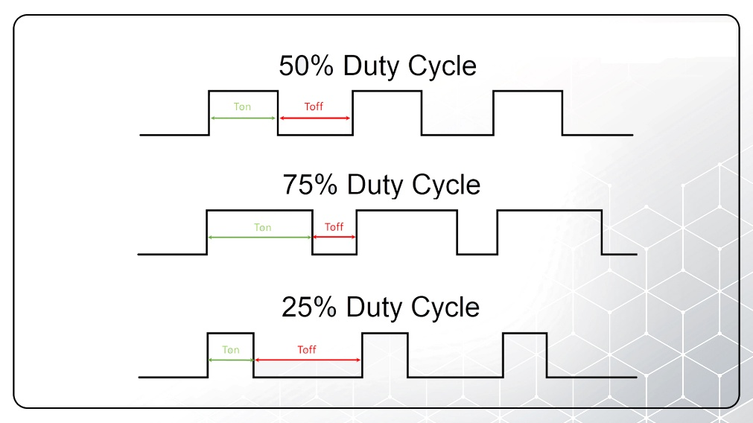

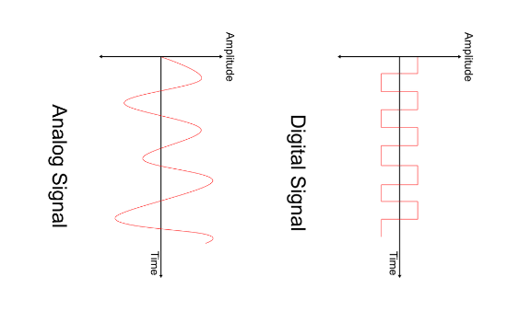

* Pulse Width Modulation (PWM) is a technique used to control the amount of power

delivered to an electrical load by varying the width of the pulses in a pulse train.

PWM is widely used in various applications, including motor control, audio amplification,

and power regulation.

**Motor Driver L298N**

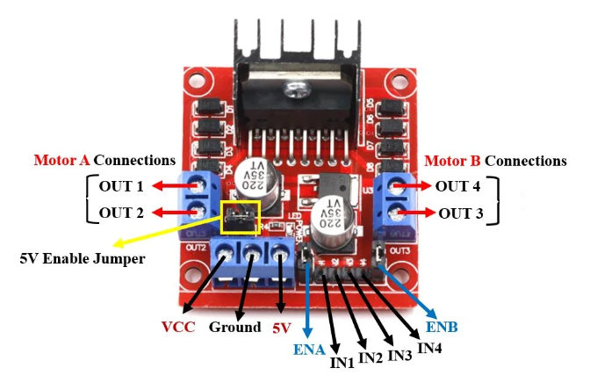

* The L293D is a motor driver IC designed to control the speed and direction of DC motors

and stepper motors. It operates on the H-bridge principle, which allows the motor to

rotate in both clockwise and counterclockwise directions by changing the polarity of the

voltage applied to it

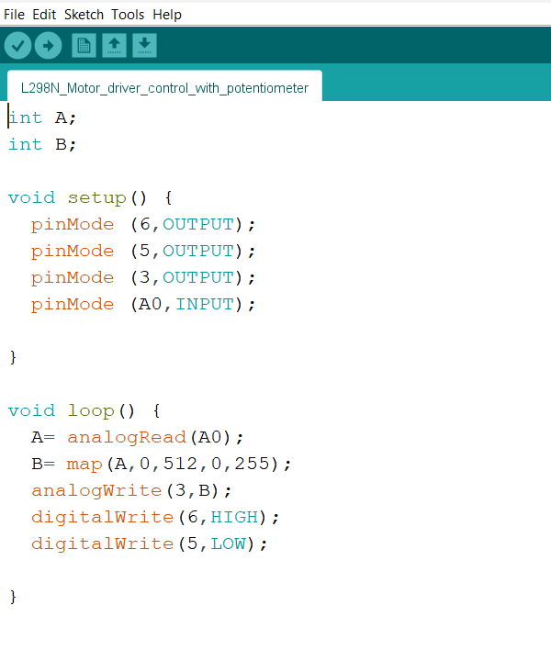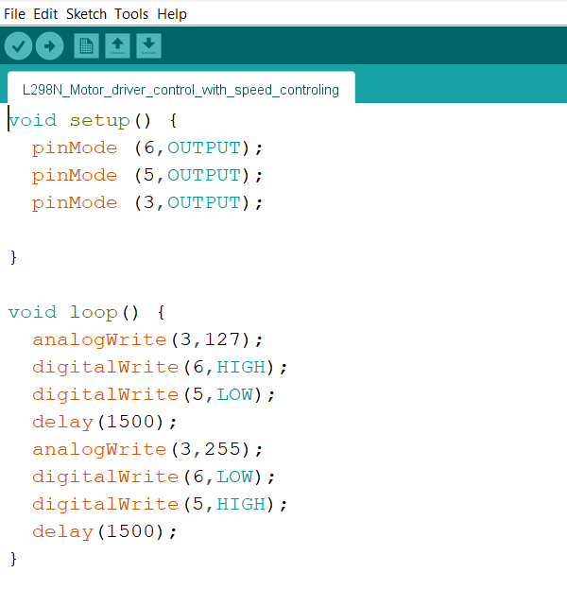





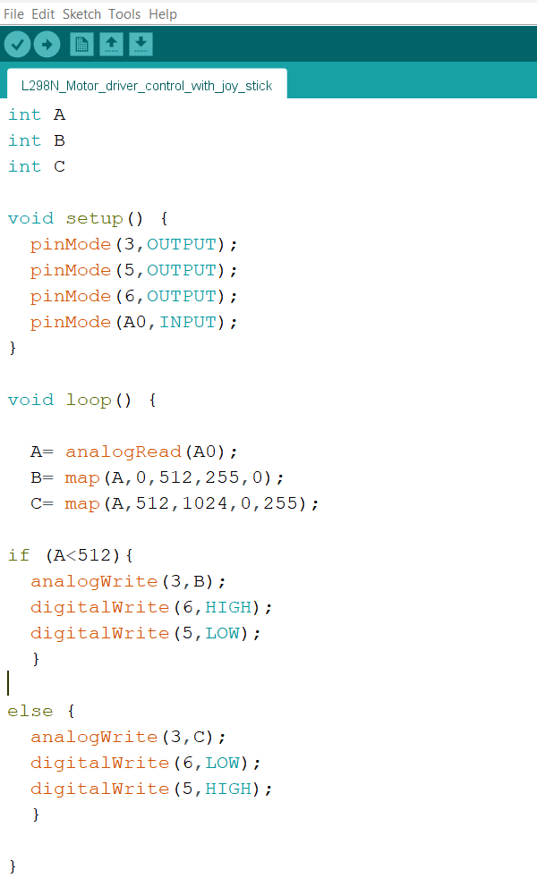



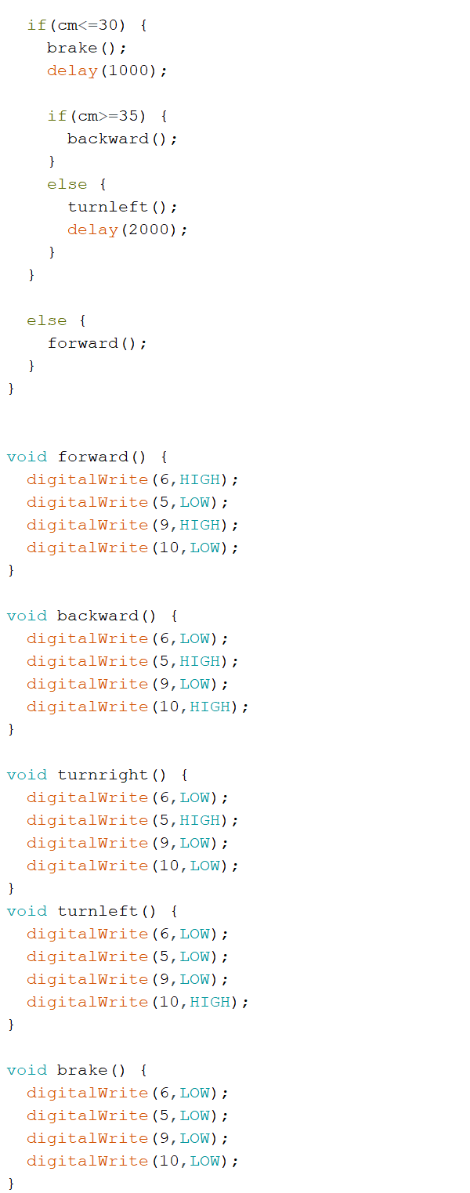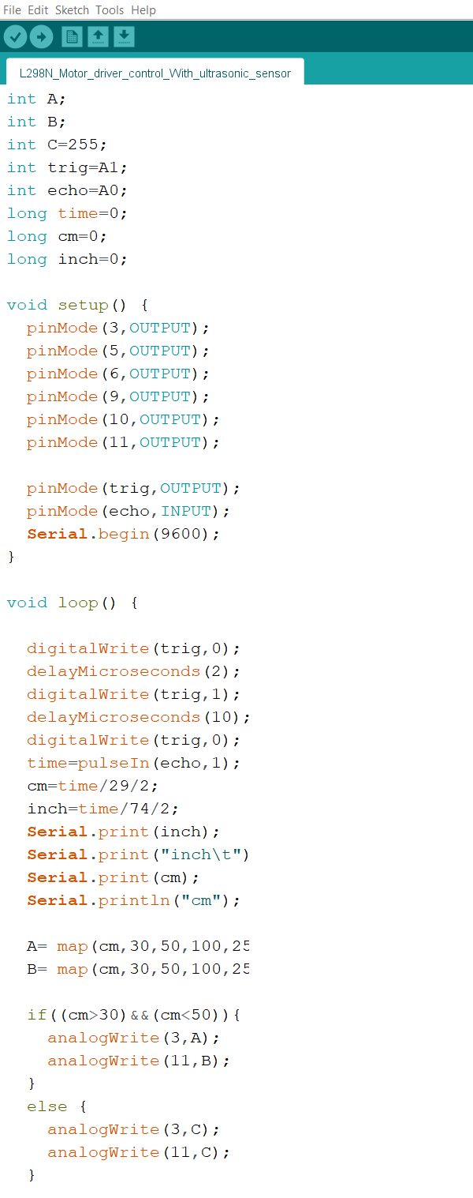



**Data Types**

**byte**

* A byte stores an 8-bit unsigned number, from 0 to 255.

|  |  |  |  |  |  |  |  |
| --- | --- | --- | --- | --- | --- | --- | --- |
| 0 | 1 | 2 | 3 | 4 | 5 | 6 | 7 |

bit

**int**

* Integers are your primary data-type for number storage.
* On the Arduino UNO (and other ATmega based boards) an int stores a 16-bit (2-byte)

value. This yields a range of -32,768 to 32,767 (minimum value of -2^15 and a maximum

value of (2^15) - 1).

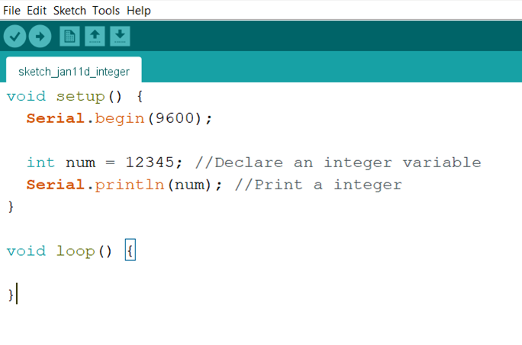



**long**

* Long variables are extended size variables for number storage, and store 32 bits

(4 bytes), from -2,147,483,648 to 2,147,483,647.

* If doing math with integers at least one of the values must be of type long.

**float**

* Datatype for floating-point numbers, a number that has a decimal point. Floating-point

numbers are often used to approximate analog and continuous values because they

have greater resolution than integers. Floating-point numbers can be as large as

3.4028235E+38 and as low as -3.4028235E+38. They are stored as 32 bits (4 bytes) of

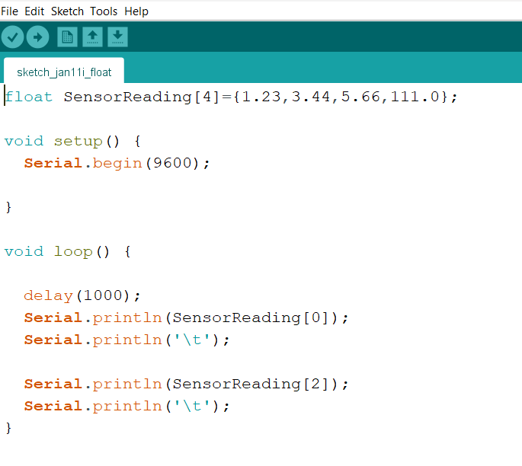 information.



**bool**

* A bool holds one of two values, true or false. (Each bool variable occupies one byte of

memory.)

**double**

* Double precision floating point number. On the UNO and other ATMEGA based boards,

this occupies 4 bytes. That is, the double implementation is exactly the same as the float,

with no gain in precision.

* On the Arduino Due, doubles have 8-byte (64 bit) precision.

**char**

* A data type used to store a character value. Character literals are written in single quotes,

like this: A (for multiple characters - strings - use double quotes: "ABC").

* The size of the char datatype is at least 8 bits. It’s recommended to only use char for

storing characters. For an unsigned, one-byte (8 bit) data type, use the byte data type.

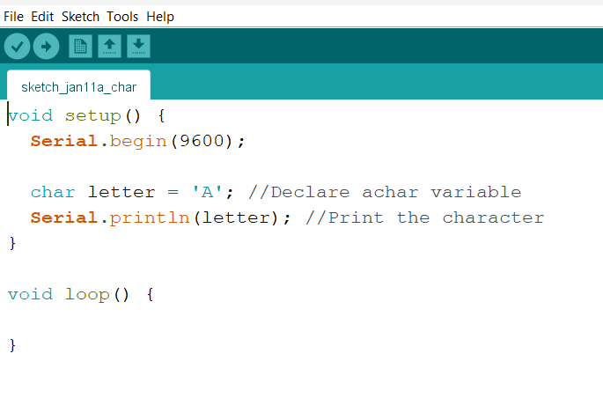



* stores a single character or a small number (1 byte )

Rangge :- 128 to 127 ( ASCII value )

**string**

* Text strings can be represented in two ways. you can use the String data type, or you can

make a string out of an array of type char and null-terminate it. This page describes the

latter method. For more details on the String object, which gives you more functionality

at the cost of more memory, see the String object page.

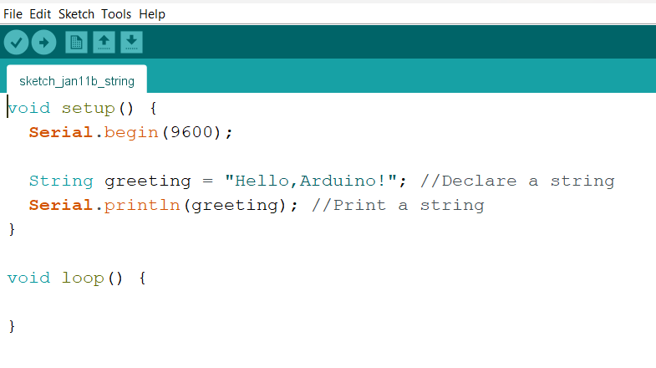



**array**

* An array is a collection of variables that are accessed with an index number. Arrays in the

C++ programming language Arduino sketches are written in can be complicated, but using

simple arrays is relatively straightforward.

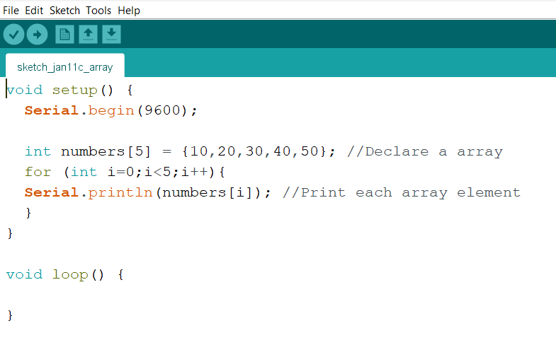



Addition Subtraction

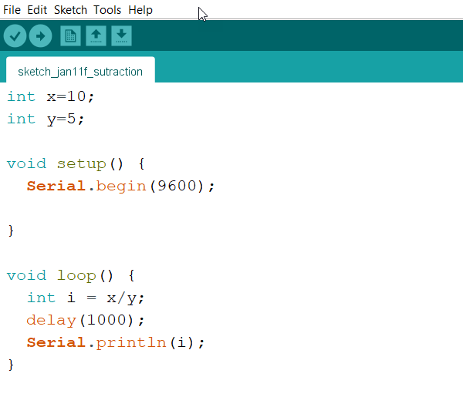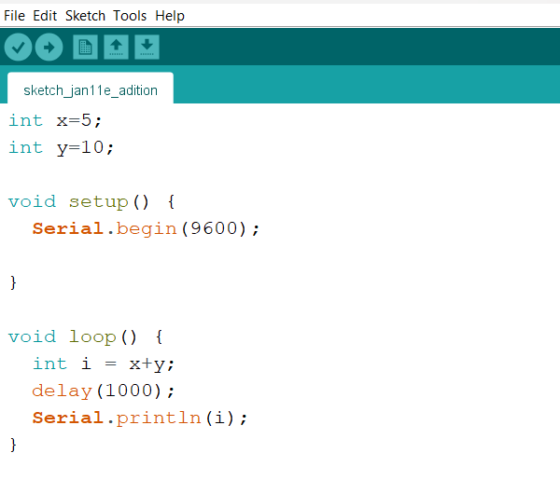



Multiplication Division

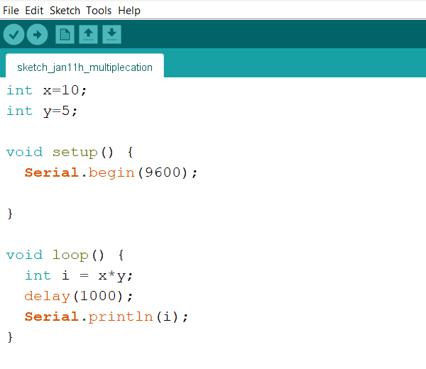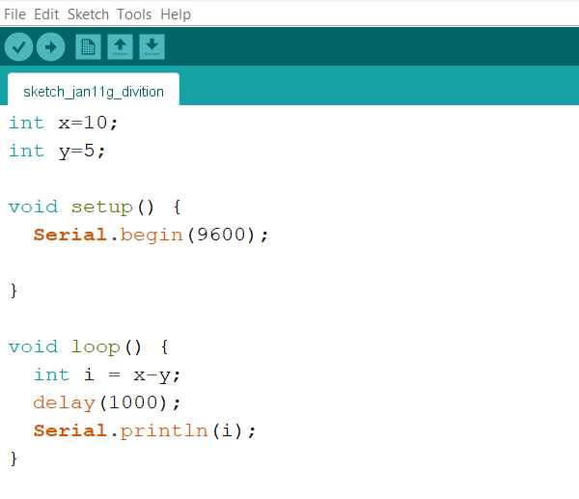



**Servo System**

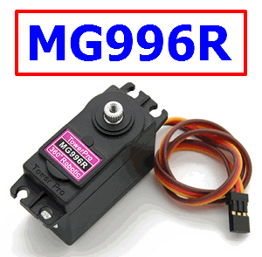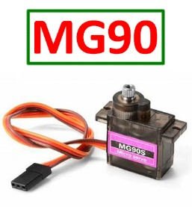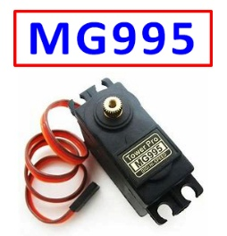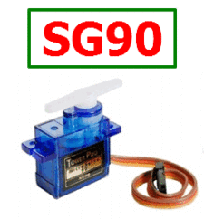

* A **servo** motor is a type of electric motor that can rotate or move to a specific position,

speed, or torque based on an input signal from a controller.